PARTS OF THE SEWING MACHINE

1. Bobbin: holds the thread inside the machine
2. Bobbin case: holds the bobbin; allows bobbin to turn and stitch; provides bobbin tension
3. Bobbin winder spindle holds the bobbin while winding the bobbin
4. Bobbin winder tension provides tension on thread when winding bobbin
5. Feed dog: moves fabric as you sew
6. Foot control Controls how fast the sewing machine sews
7. Hand wheel controls the movement of the take up lever and needle; can be controlled by power or by hand; should ALWAYS be turned toward you.
8. Power switch turns off/on machine and light bulb
9. Needle Carries the thread and pierces the fabric
10. Presser foot holds fabric in place while you sew
11. Reverse control allows machine to stitch backward
12. Presser foot lever lifts and lowers the presser foot
13. Spool pin holds the spool of thread in place
14. Stitch pattern selector shows you which pattern the machine will sew
15. Stitch width control sets the width of the zig zag stitch
16. Take up lever pulls thread from the spool
17. Thread cutter a place to cut threads without using scissors
18. Thread tension control adjusts the tension on the thread as required for a particular project

PARTS OF THE SEWING MACHINE
Study guide and quiz

1. Bobbin: 2. Bobbin case:
3. Bobbin winder spindle 4. Bobbin winder tension
5. Feed dog: 6. Foot control
7. Hand wheel 8. Power switch
9. Needle 10. Presser foot
11. Reverse control 12. Presser foot lever
13. Spool pin 14. Stitch pattern selector
15. Stitch width control 16. Take up lever
17. Thread cutter 18. Thread tension control

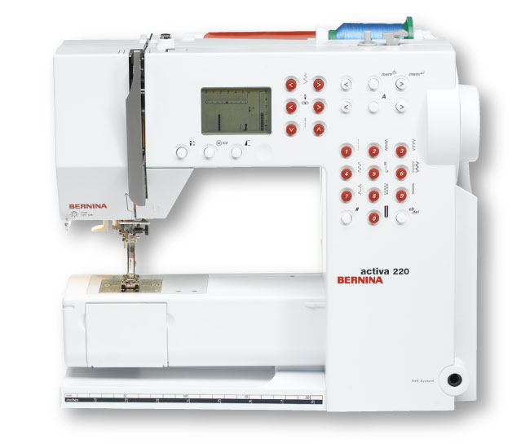
RULES FOR USING THE SEWING MACHINE

The procedures and rules for using the sewing machines are:

- Before beginning to sew, pull threads UNDER and BACK behind the presser foot about 3 to 4 inches.
- The hand wheel always turns toward you, even when stitching in reverse.
- Keep fingers several stitches away from stitching line; keep them flat on the machine to the sides of the presser foot
- The presser foot must always be in the “down” position for sewing.
- Don’t force or pull the fabric- the machine will feed automatically.
- Use the thread cutter to cut thread tails or trim threads with scissors as you work
- The take up lever should always be at the “top” when beginning and ending line of sewing.
- Report any repairs needed.
- Maintain a slow and even speed with the foot control.
10. Watch the seam guide as you sew (NOT THE NEEDLE) to
produce and even sewing line.
- When stopping in the middle of a line of sewing put the needle down into the fabric to prevent thread loops.
- Keep the bulk of the fabric to the left of the needle when sewing so you can see the seam guides on the needle plate.
- Do not sew over pins.

The sewing machine is a very powerful and expensive piece of machinery. I will use the machine as instructed. By not following these directions I may risk bodily injury and will forfeit the privileges of working on the machine. I will be given worksheets to make up for projects that I have not completed.

STUDENT SIGNATURE________________________________

